Picture Guide to adding “Find Recent Documents” to your computer’s Start menu.
Look at the bottom left corner of your monitor for your start button. Mine looks like this:
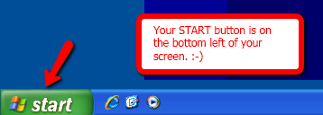
Left click on your Start button.

Then right click on a blank place on the right half of the menu display.
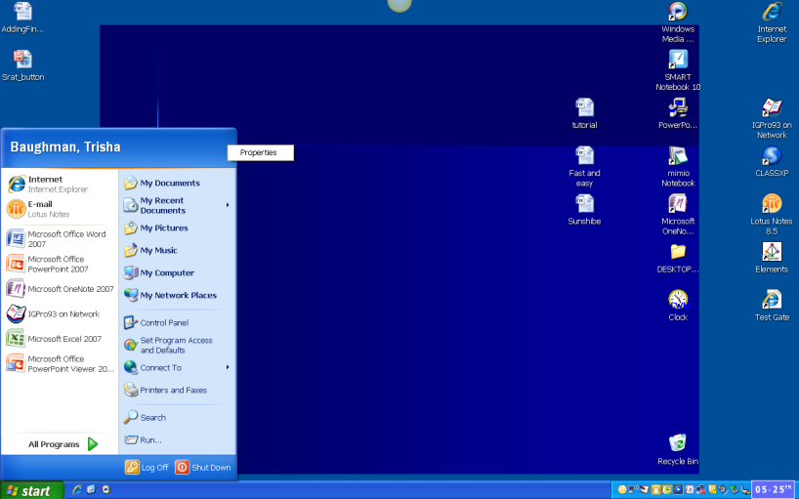
A button saying “Properties” will appear. Left click on “Properties.”
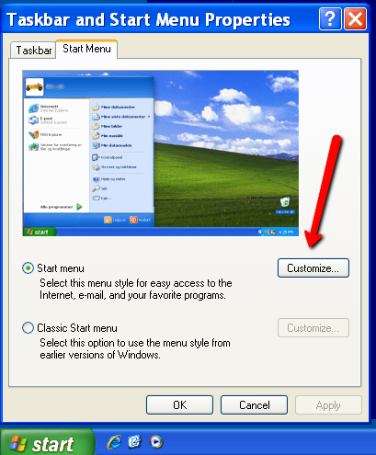
Then click Customize
Then pick Advanced.
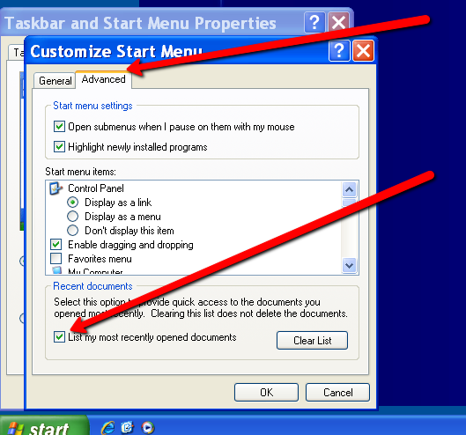
Check to list Recent Documents.
From now on, just click your start menu and then My Recent Documents. You will never misplace a document again!
