Evidence in research proves that Albert Einstein focused his life on using his strengths. Howard Gardner’s Theory of Multiple Intelligences shows that Einstein was strong in Logical/Mathematical and Nature

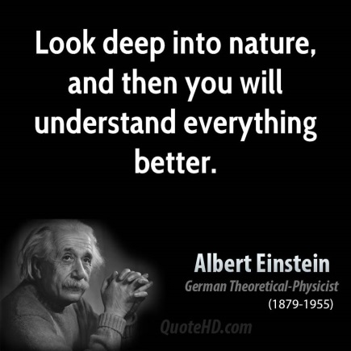

By
Sample FOCUS Student
Mr. Dozier’s Class

Albert Einstein is one of the world’s most well-known scientists. He is famous for his theories in physics, which is a type of science. The Funk and Wagnall’s Encyclopedia mentioned that when Einstein was a teenager, he learned geometry, which is a type of mathematics, on his own from reading books and teaching himself. His strengths were definitely Logical and Mathematical. In fact, the booklet we are reading by Michael Emerson states on page 7 that his talents for math and science were clear very early in school.
Einstein also enjoyed philosophy and wanted to understand the nature of things like magnetism, matter and light. The Funk and Wagnall’s Encyclopedia stated that physicists and chemists were called “Natural Philosophers” and people like Sir Isaac Newton, who wanted to understand how the nature of things fit into a unified big picture, were known as Natural Philosophers. Therefore, Einstein also had a strength in what Howard Gardner would describe as Naturalist. The RAZ Kids book shows a picture of him on page 18 enjoying being outside sailing. He wanted to explore the nature of the universe, and one of his famous quotes on the internet is, “Look deep into nature, and you will understand everything better.”
Einstein had many areas in which he was not as strong. He was not well-liked by his teachers and even some fellow scientists did not believe or support his ideas. He kept writing up his ideas and theories, which led to his being well-known. When he won the Nobel Prize in 1922, he became even more famous. He used the power of his fame to try to help people get along and avoid war. Einstein spoke out against his country of Germany entering World War I. Later, when he did not agree with his native country of Germany supporting Hitler’s vision, he switched his citizenship to the United States and wrote a letter to the President Franklin D. Roosevelt warning that Germany might be trying to make an atomic bomb. Although he had been anti-war, his letter led to the building and use of the atomic bomb, which killed many people in World War II. After the war, he continued to try to get people to live peacefully and did not accept a leadership position when he was offered the Presidency of Israel. Instead, he kept working as a physicist, using his personal strengths, until he died.

The encyclopedia said that Einstein’s scientific theories and his social theories were based on his intuition as well as evidence and observation. The evidence showing his strengths was found in:
Funk and Wagnall’s Encyclopedia, 1986, page 124-127
RAZ Kids Reading A-Z Albert Einstein by Michael Emerson
QuoteHD.com

